Retail Banking
(Internal Project)



TABLE OF CONTENTS
1.Team Members
2.Overview
3.Software Prerequisite
4.Architecture Diagram
5.Implementation
6.Required APIs
7.Swagger
8.Testing

1.TEAM MEMBERS
Full Name | Role
Sneha Dhanraj Suryawanshi | Mentor
Mahesh Pandurang Karambalakar | Mentor
Sushant Sunil Poman | Developer
Saurav Kumar Mishra | Developer
Alfiya Mahvish Aabid Khan | Developer
Sumit Jaiswal | Developer
Narindi Sravana Lakshmi | Developer
Patel Dhiren Rajnikant | Developer
Sandeep | Developer

3.OVERVIEW
This project aims to develop a scalable, maintainable, and secure application for a leading retail bank using microservices architecture with Spring Boot. The application will manage core banking functions, including Accounts, Customers, and Transactions. The objective is to ensure that the application can handle increased transaction volumes during peak times and facilitate easy updates and maintenance of individual Services.

4.SOFTWARE PREREQUISITE
Tech Stack:
- Java Version 17
- Spring Boot 3.4.1
- Rest API
- Authentication with JWT Token
- API Gateway
- Eureka Server
- Feign Client
- Config Server
- Postgres SQL
- Zipkin
- Junit/Mockito

Tools:
- Spring Tool Suite
- Postman
- Pg Admin 4
- Intellij Idea
- Github
- Swagger

Microservices:
- Customer Service
- AccountManagement Service
- Transaction Service
- Auth Server
- Config Server
- Eureka Server
- Api Gateway

4.ARCHITECTURE

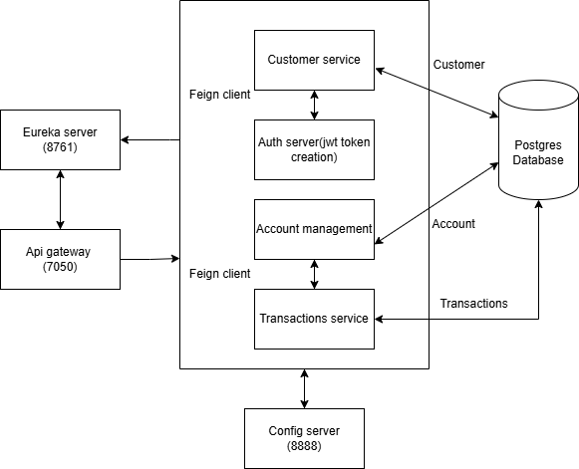

1.Client Request: The client sends a request to the API Gateway (Port 7050)
2.Service Discovery: The API Gateway consults the Eureka Server (Port 8761) to discover the appropriate microservice instance dynamically.
3.Request Routing: Once the service is discovered, the API Gateway routes the request to the correct microservice.
4.Authentication: The Auth Server authenticates the request by validating the JWT token provided by the client. If valid, it allows the request to proceed.
5.Service Communication: If needed, the microservice communicates with other services using Feign Clients for seamless RESTful interactions.
6.Accessing Data: The microservice interacts with the Postgres Database to read or write the necessary data.
7.Config Retrieval: The microservice retrieves its configuration properties from the Config Server (Port 8888), ensuring it has the latest settings and environment-specific configurations.
8.Response: After processing the request, the microservice sends a response back to the API Gateway, which then forwards it to the client.

5.IMPLEMENTATION
Zipkin Server:
Steps to start Zipkin server :
- Visit the Zipkin repository (Central Repository: io/zipkin/zipkin-server) and download the JAR file: zipkin-server-3.0.4-exec.jar.
- This JAR file is compatible with Java 21.
- Once downloaded, navigate to the location where the JAR file is saved.
- Execute the following command to run the JAR file:
java -jar zipkin-server-3.0.4-exec.jar.
- Once the JAR file starts, you will be able to see the Zipkin interface.
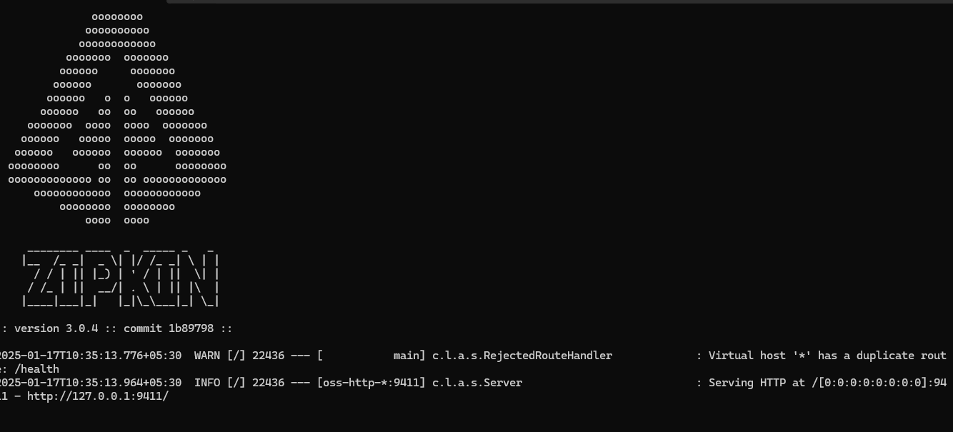
Steps to stop Zipkin server :
7. Open Task Manager using the shortcut: Ctrl + Shift + Esc.
8. Go to the Details tab (located in the left sidebar).
9. Type java in the search bar to locate the running JAR file.
10. Once you find the JAR file, select it and click End Task.

Eureka Server:
All microservices, such as account management, transaction processing, customer service, and authentication service, are registered in Eureka
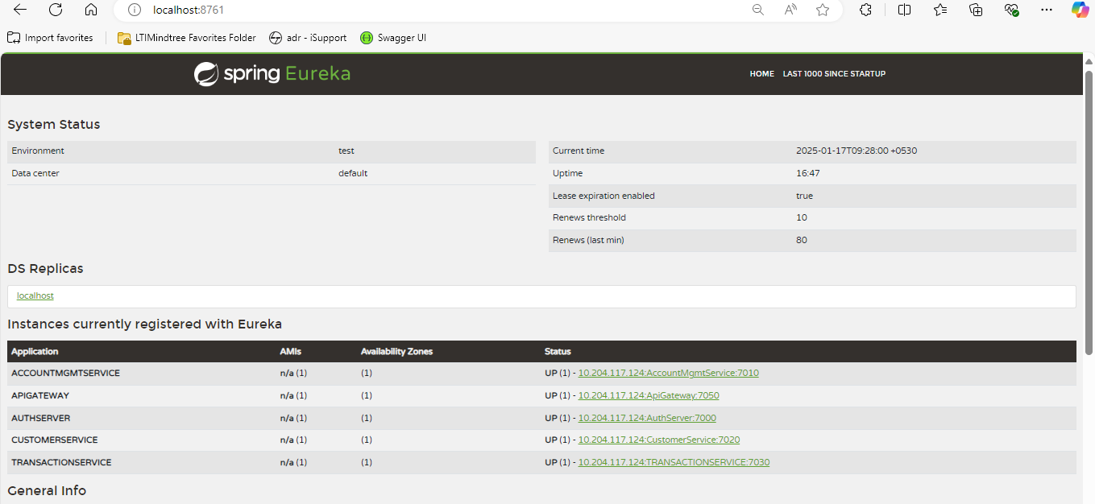

5.REQUIRED API’s
Customer Service:
HTTP Request | End Point | Description
GET | /customers/customerById/{customerId} | Retrieves the details of a customer by their ID.
POST | /customers/register | Creates new customer account
POST | /customers/login | Validates a customer's credentials using their email and password
GET | /customers | Retrieves a list of all customers
PUT | /customers/updateCustomer/{customerId} | Updates the details of a customer with the specified ID
GET | /customers/customerByRole/{role} | Retrieves a list of customers based on their role
GET | /customers/ageCategory/{customerId} | Retrieves the age category of a customer by their ID.
POST | /customers/logout | Customer can logout.

Account Management Service:
HTTP Request | End Point | Description
POST | /accounts | Creates a new account.
GET | /accounts/{accountNo} | Retrieves an account-by-account number
PUT | /accounts/balance/{accountNo} | Updates the balance of an account
GET | /accounts/balance/{accountNo} | Retrieves the balance of an account
DELETE | /accounts/{id} | Deletes an account by ID
PUT | /accounts/updatestatus | Updates the status of an account.
PUT | /accounts/updateMinBalance | Updates the minimum balance for a specified age category.

Transactions Service:
HTTP Request | End Point | Description
POST | /transaction | Performs a new transaction
POST | /transaction/statement | Fetches all transactions for a particular account
POST | /transaction/transfer | Performs a fund transfer
GET | /transaction/transactionPeriod | Retrieves transactions for a specific account within a given date range.

6.SWAGGER
Auth Service:
- Auth Login
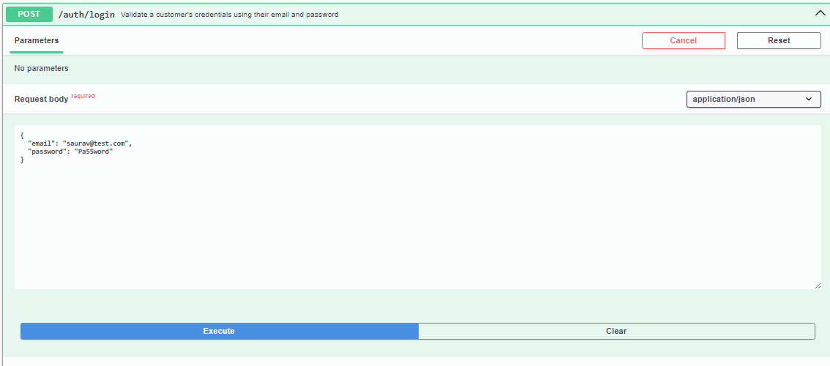
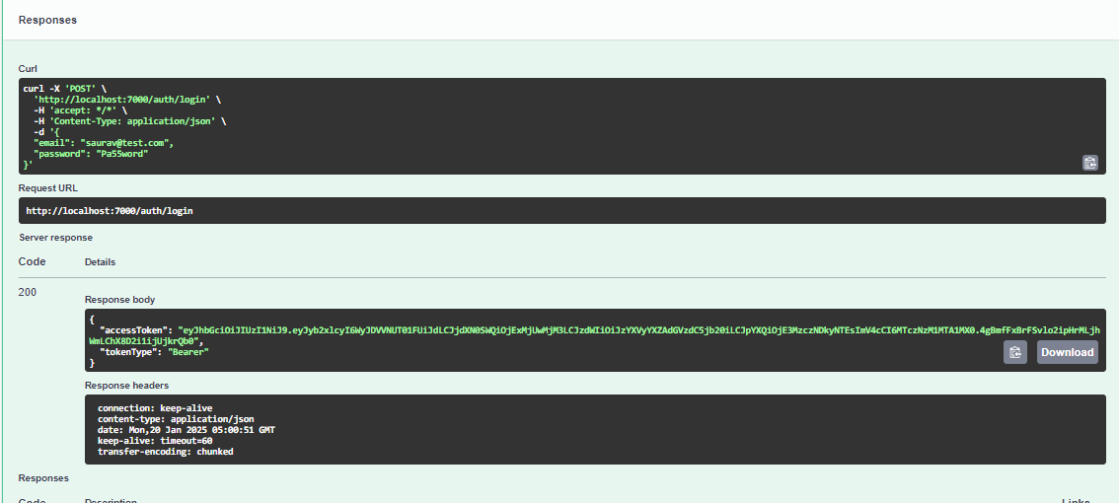

Customer Service:
- Create customer account
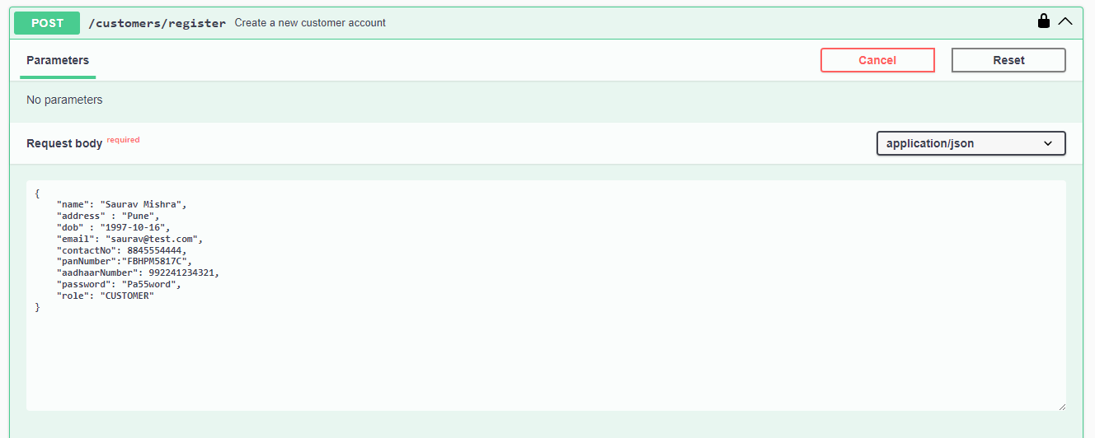
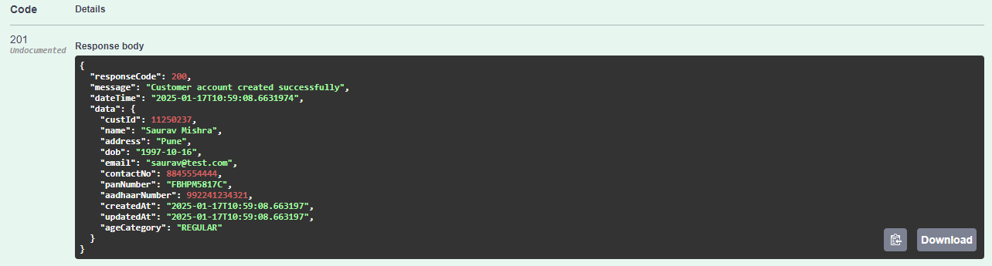
- Get All Customers

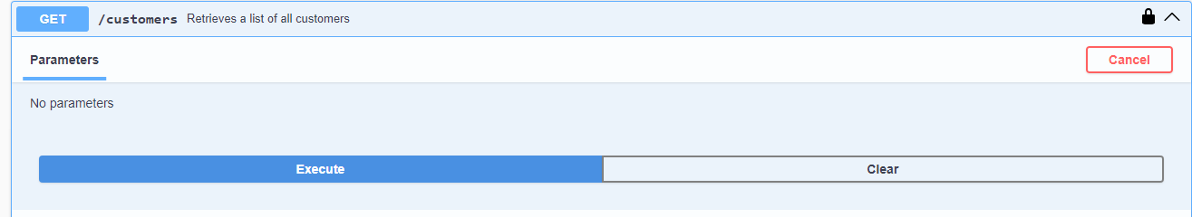
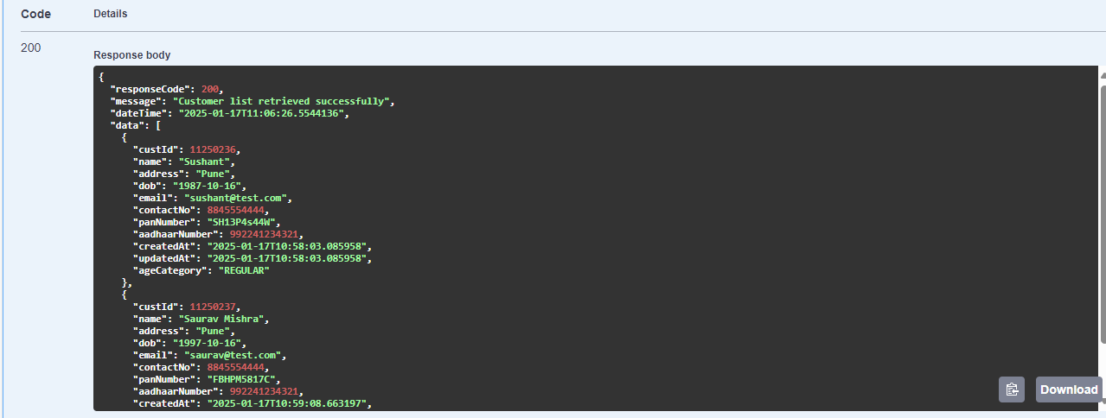
- Get Customer By Id

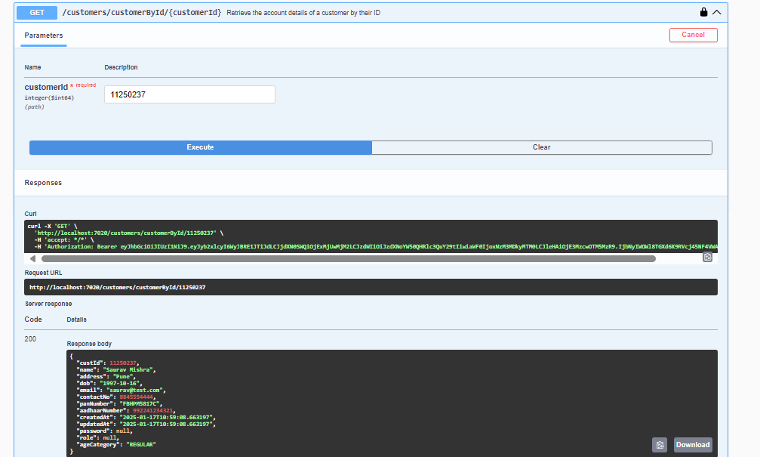

- Get Age Category By CustomerId

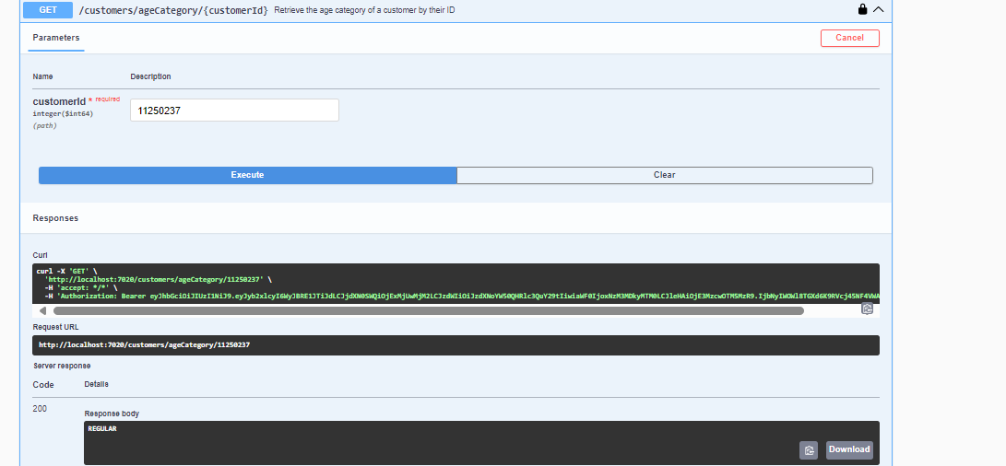

- Update Customer Details
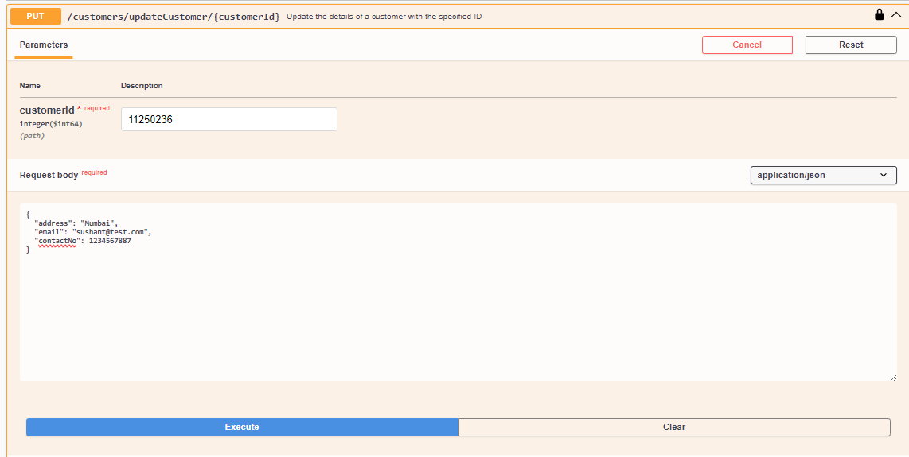
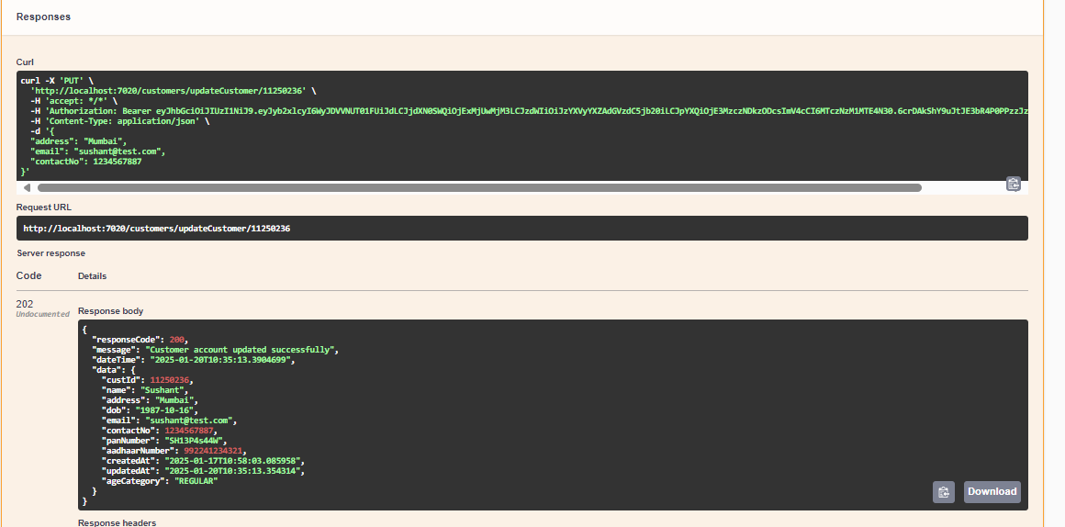

- Customer Logout

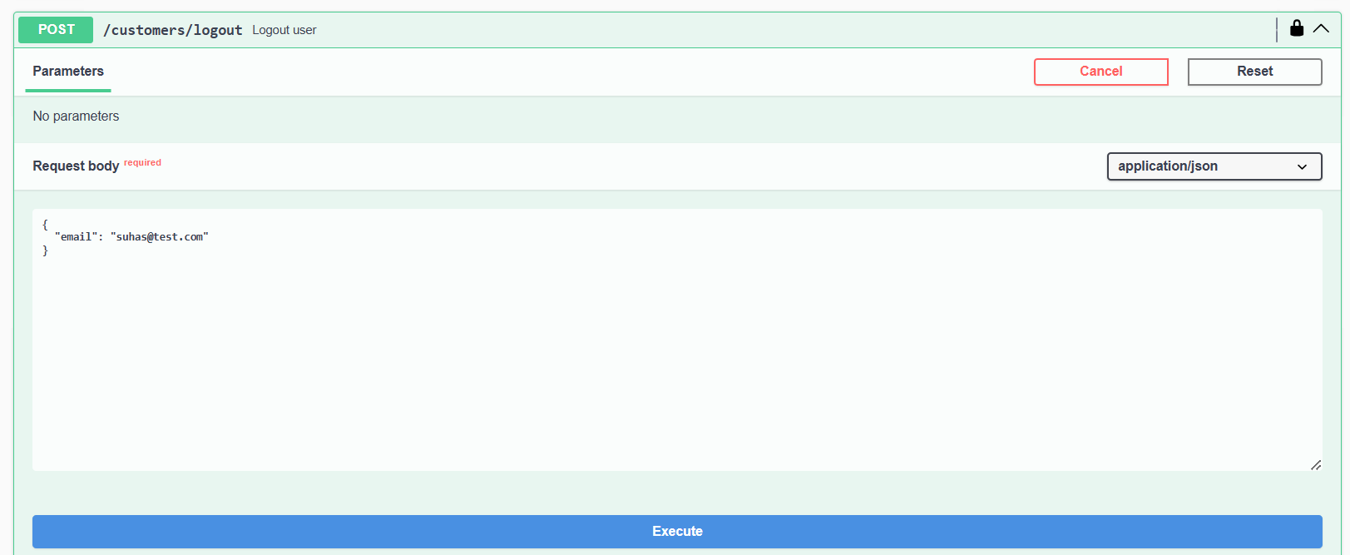
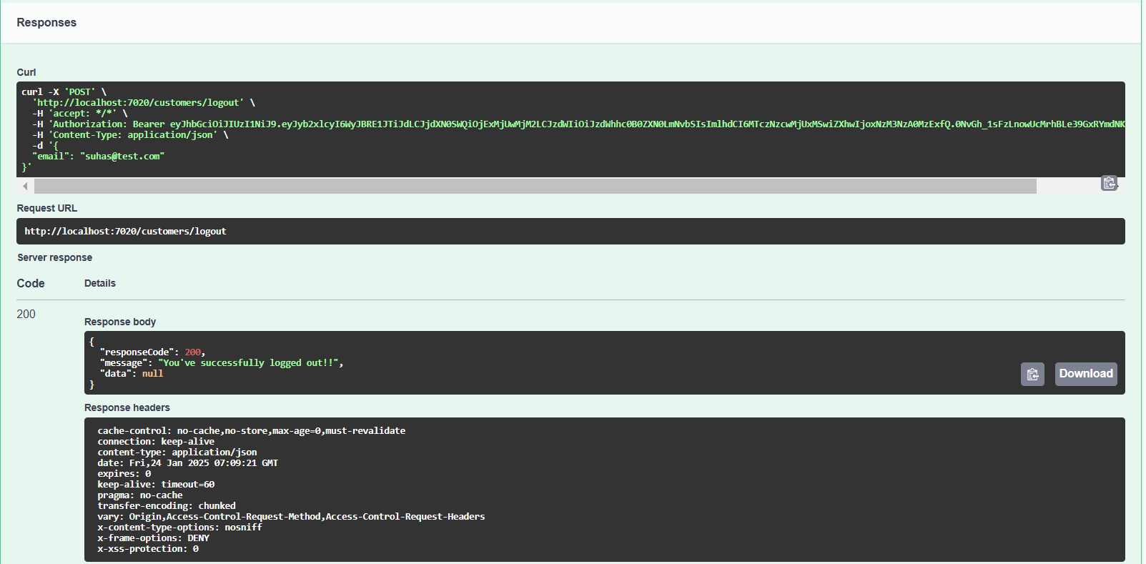

Account Management Service:
- Create Account
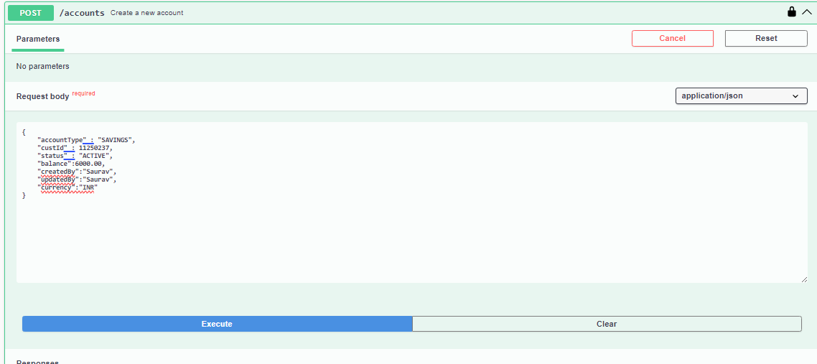
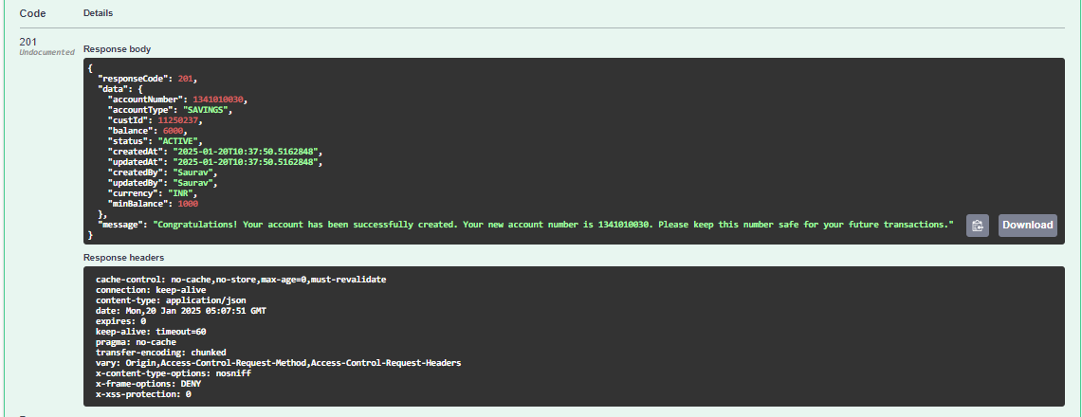

- Get Account details by AccountID
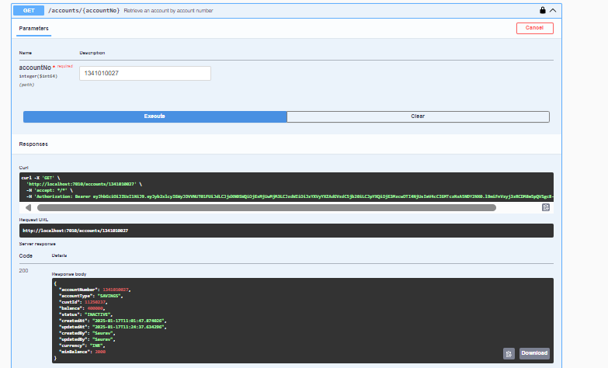
- Updates Account Balance
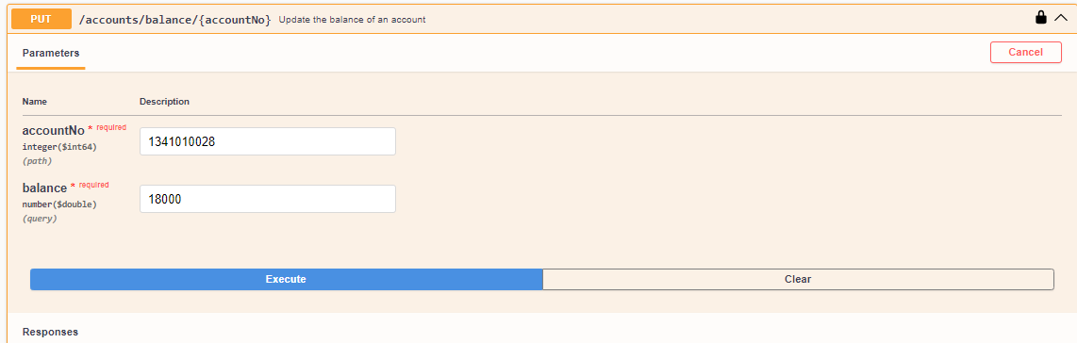
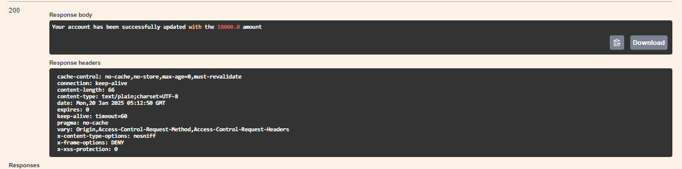

- Get Balance of Account by AccountID
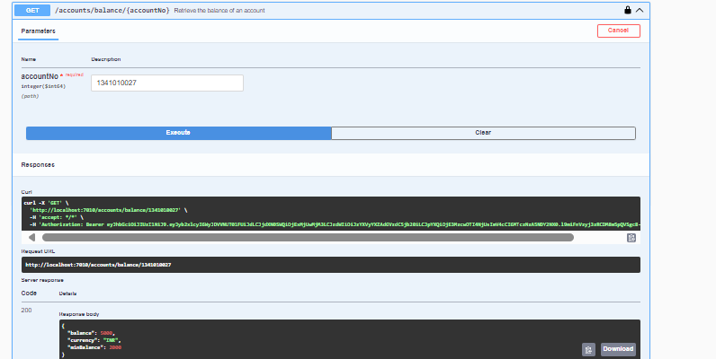

- Update Account Status
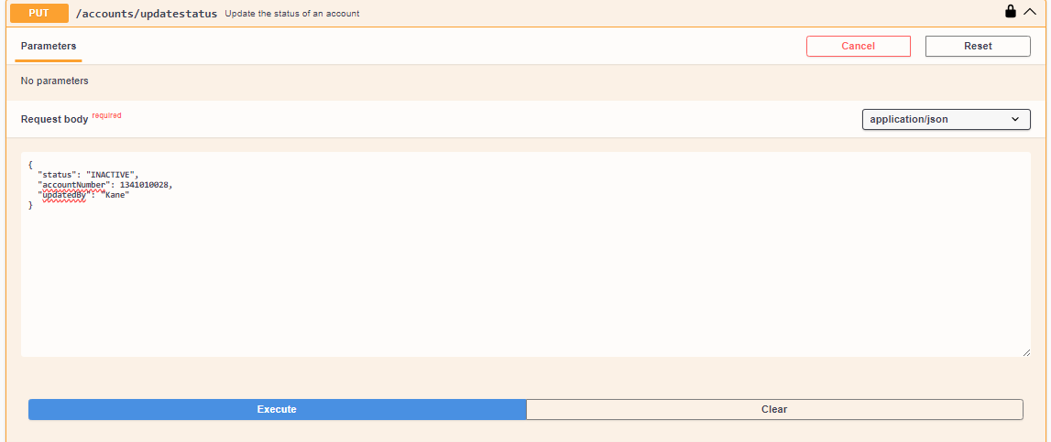
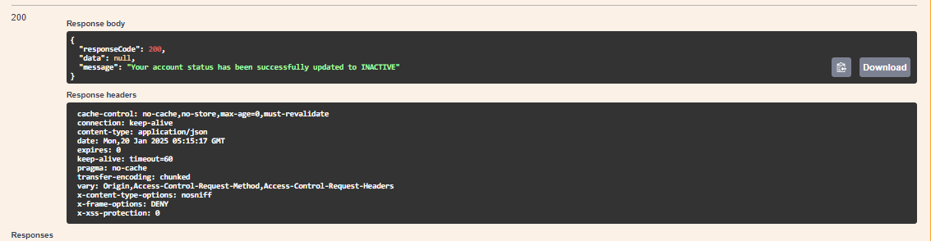

- Updates Min Balance for Specific Age Category
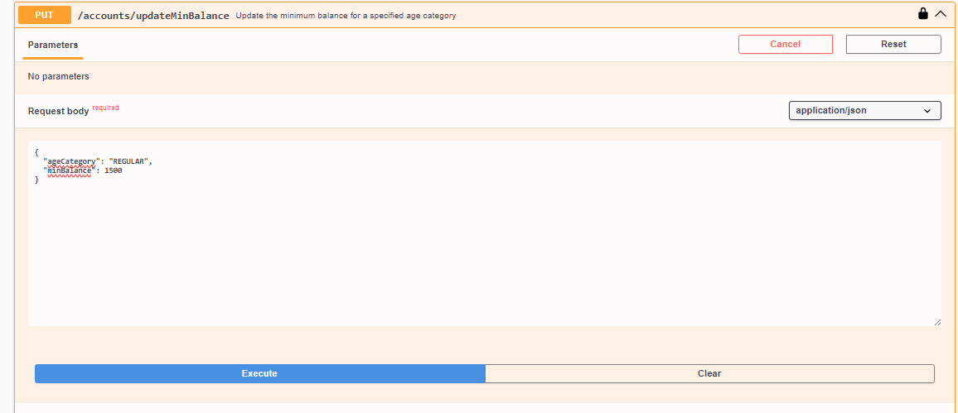
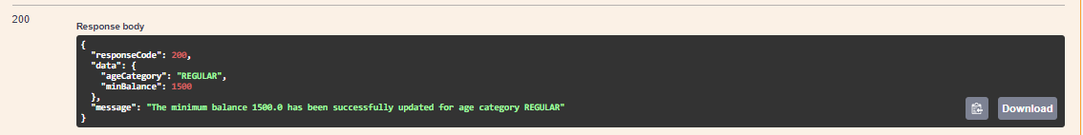

- Delete Account By AccountID
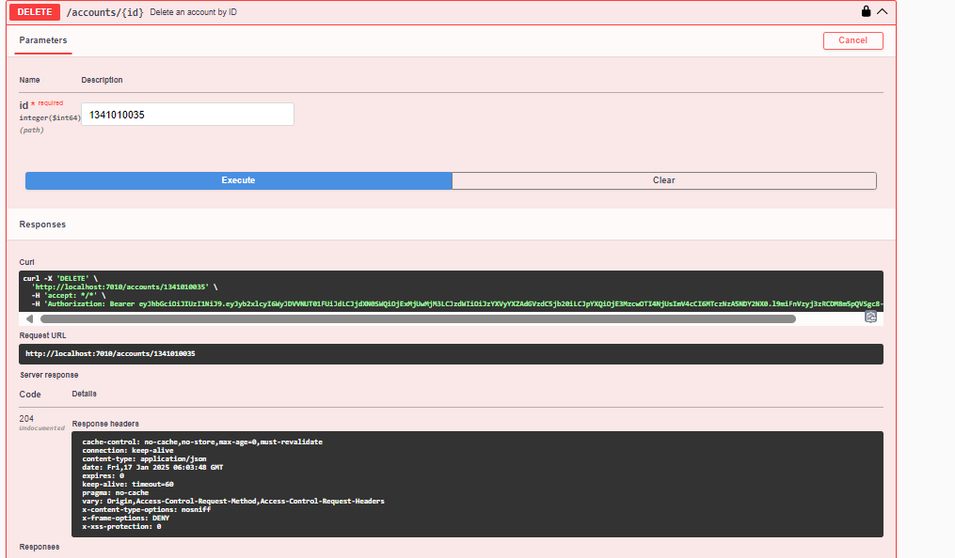

TRANSACTION SERVICE:
- Performs new transaction
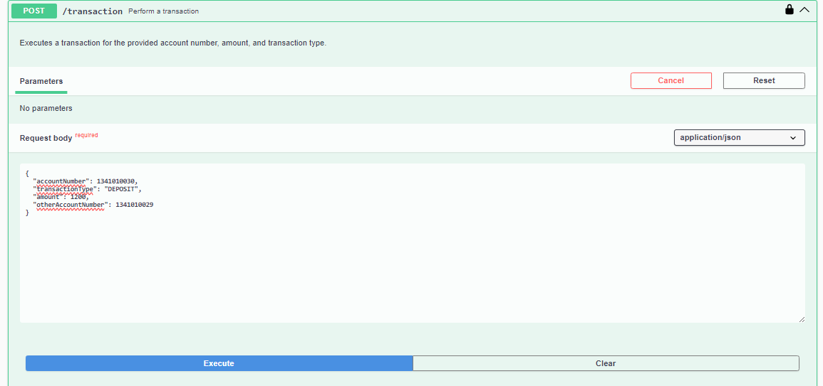
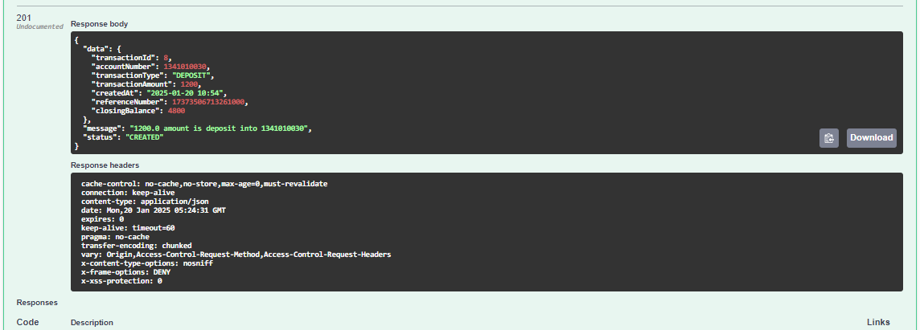

- Get all Transactions for Particular Account
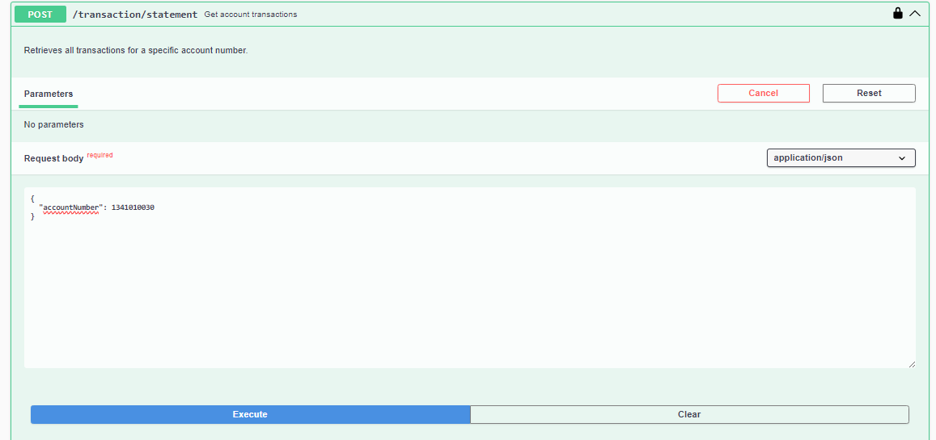

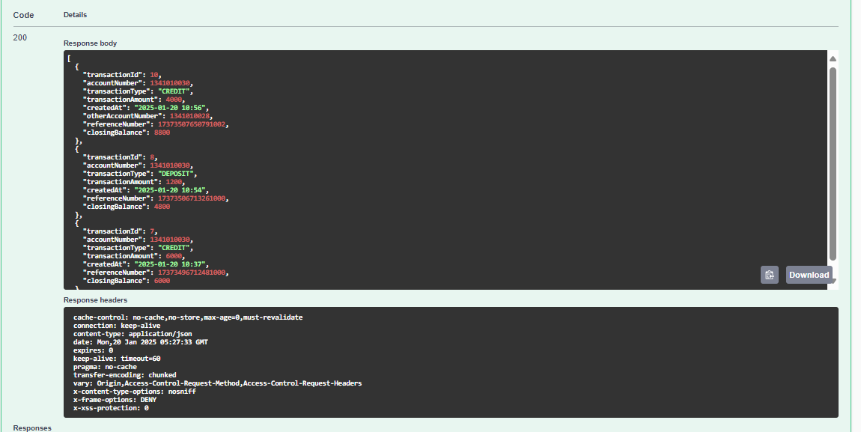

- Performs a Fund Transfer
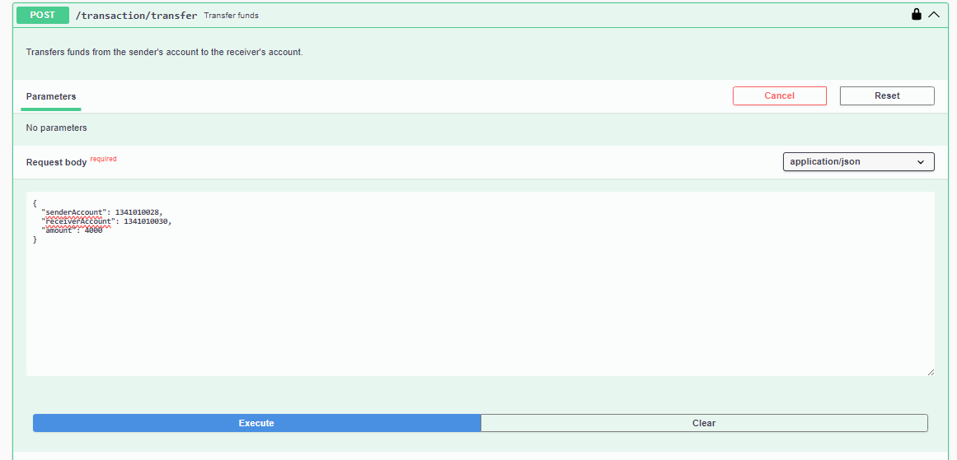
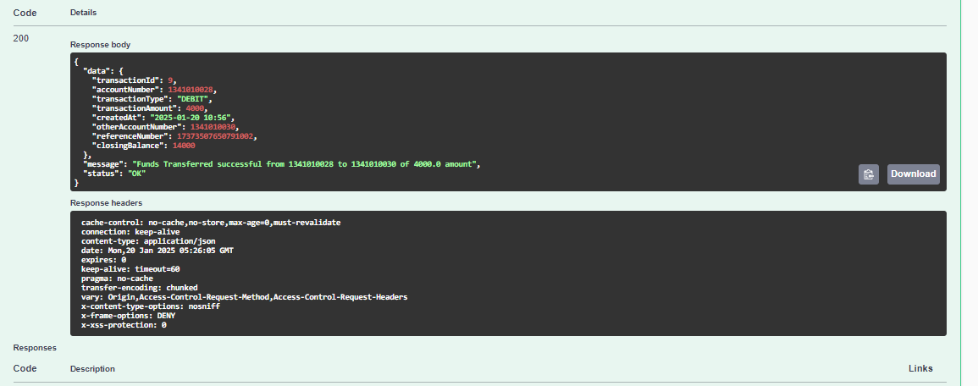

- Retrieves transactions for particular time period

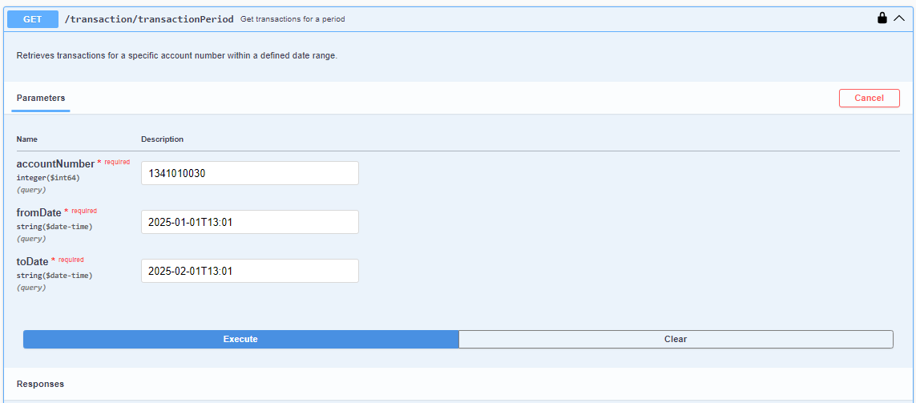
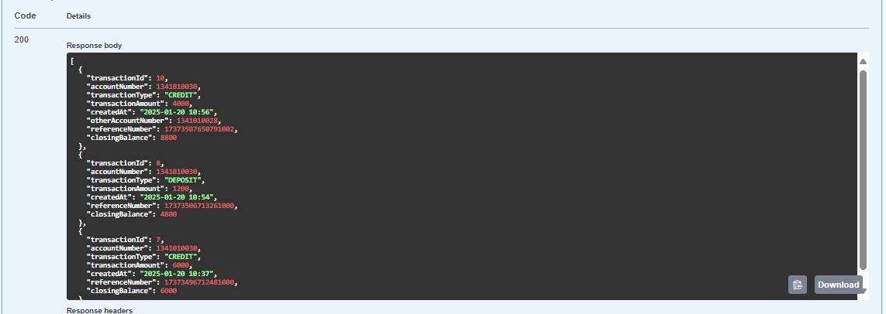

7.TESTING

We have implemented comprehensive unit testing using JUnit and Mockito for all microservices. Our testing strategy ensures that each unit of code, typically a function or a class, is tested in isolation.

Key Highlights:
- Testing Frameworks: JUnit and Mockito.
- Test Coverage: Achieved over 80% code coverage across all microservices.
- Objective: Ensure code quality, identify bugs early, and validate individual units of code for expected behavior.

